Fundamentals of Data Visualisation

Class Activity: Hands-on Exercise

Nokin Cameras

World-wide sales of digital cameras are really hurting now that people are not travelling and taking photos due to the Covid-19 pandemic. As the world-wide marketing manager for Nokin Cameras Inc. you have come up with a novel concept to boost sales.

Model ZV-1 is specially designed for videoconferencing and social media marketing purposes. It is aimed at the group of influencers, content creators and online marketers wanting to create insanely great photos and compelling videos with little or no knowledge of photography or videography.

Based solely on the Covid-19 data provided to you, prepare a convincing marketing plan which includes the following:

1. An update of the Covid-19 situation globally.
2. Review the Covid-19 situation in 7 key Nokin markets: US, UK, Germany, Japan, South Korea, Australia and China.
3. Propose three countries to launch the product with supporting reasons.

# First Things First – Preparation of Data

1. Bring in Excel file “owid-covid-data_0928s.xls” into Tableau.
2. Add text file “Locations.csv” into Tableau via “Add”.

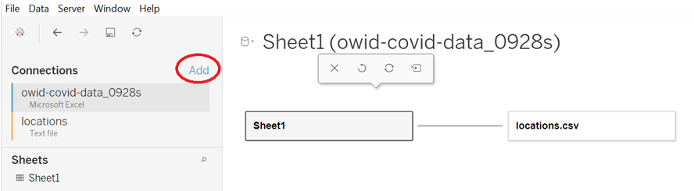

1. Define the relationships: By Continent, By Country.

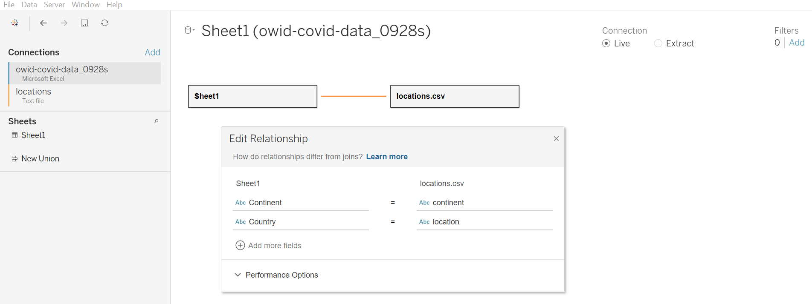

1. Check and define the data types, where necessary:
2. iso-code:  
   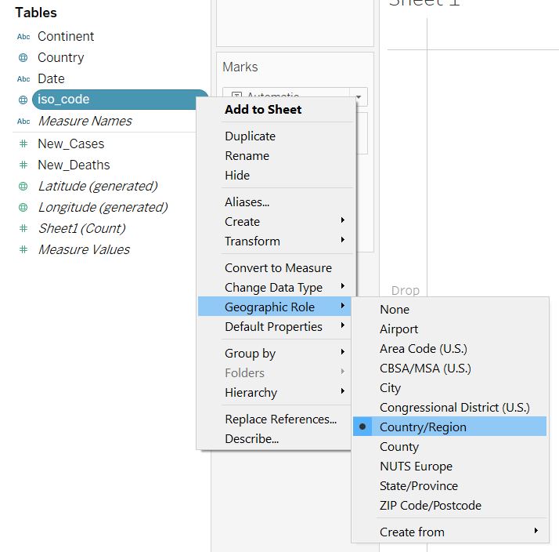
3. Date:  
   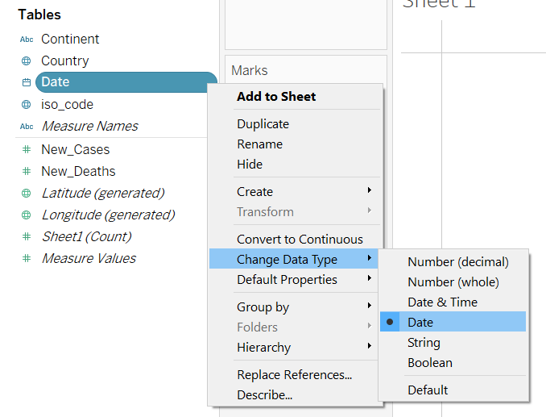
4. 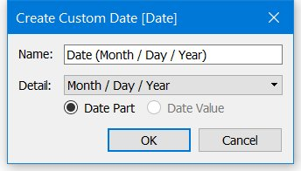Create Customised Date Formats:  
     
   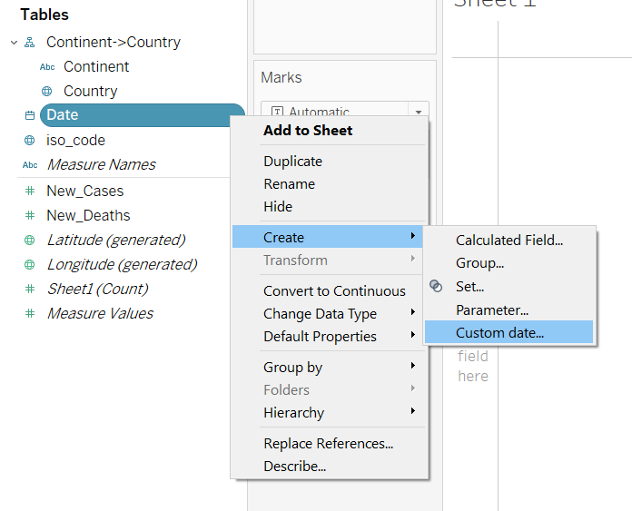

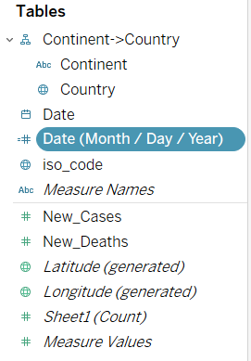

1. Define Hierarchies:  
     
   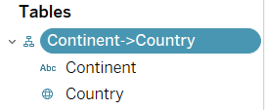
2. Exclude redundant/irrelevant data

Step a: Drag the following to Rows Shelf:

* Hierarchy Continent-Country
* New Cases
* New Deaths

Step b: From Show Me, select Text Table

Step c: From Rows Shelf, click on  of “Continent” to expand.

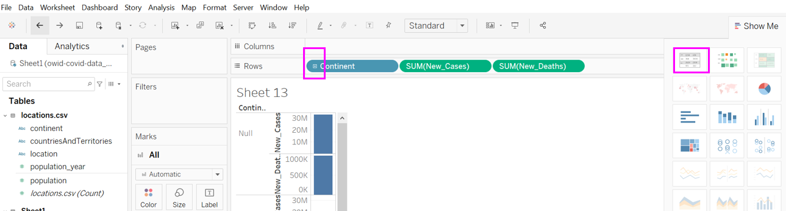

Step d: Right click on “Null” in the table, then select “Exclude” as shown below:

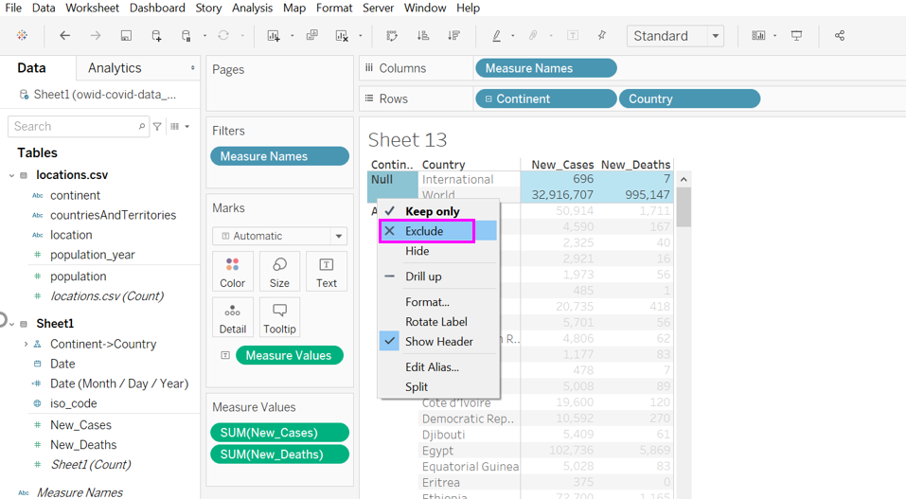

1. Filter only the relevant data to use:

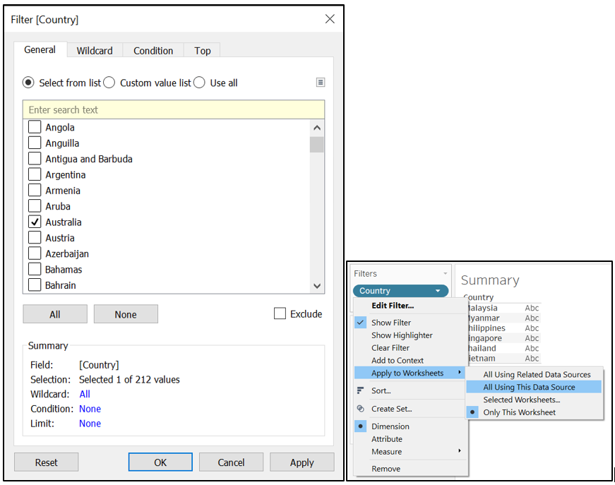

Sample Charts:

